TITLE OF THE REASEARCH PROJECT

A dissertation submitted to the

Department of Computer Science and Informatics,
Faculty of Applied Sciences,
Uva Wellassa University
in partial fulfillment of the requirements for the award of the Degree of ………………….. (mention the name of the degree)

by

FULL NAME OF THE CANDIDATES

Department of Computer Science and Informatics
Faculty of Applied Sciences

Uva Wellassa University, Sri Lanka

September 2025

DECLARATION

I do hereby declare that the work reported in this dissertation was exclusively carried out by me under the supervision of (Name of the supervisor/s). It describes the results of my own independent research except where due reference has been made in the text. No part of this dissertation has been submitted earlier or concurrently for the same or any other degree.

Date: ……….. …………………………
Signature of the Candidates

(Contact Details of the Candidates)

We endorse the declaration by the candidate(s).

…………………………………… ………………………………….
Signature of the Supervisor Signature of the Co-supervisor

……………………………………. ………………………………..
Name of the Supervisor Name of the Co-supervisor

Date: …………………. Date: ………………….

………………………………….
Signature of the Co-supervisor (If need)

………………………………..
Name of the Co-supervisor (If need)

Date: ………………….

Acknowledgement

Contents
 |  |  |  |  |  |  |  | Page
Declaration |  |  |  |  |  |  |  | i
Acknowledgement |  |  |  |  |  |  |  | ii
Contents |  |  |  |  |  |  |  | iii
Abstract |  |  |  |  |  |  |  | iv
Table of |  |  |  |  |  |  |  | v
List of Figures
List of Tables
List of Abbreviations
1. | Introduction
 | 1.1 |  |  |  |  |  |  | 1
 | 1.2 |  |  |  |  |  |  | 2
 |  | 1.2.1 |  |  |  |  |  | 2
 |  | 1.2.2 |  |  |  |  |  | 2
2. | Literature Review |  |  |  |  |  |  | 4
3. | Materials and Methods
4. | Results and Discussion
5. | Conclusions
 | References
 | Appendix

Abstract

An abstract (300 words maximum) is required which summarizes the contents of the dissertation. It should state the problem being examined, the procedure or methods used, the results and any conclusions that are drawn.

Keywords: Max. five (5)

LIST OF FIGURES

LIST OF TABLES

LIST OF ABBREVIATIONS

Chapter 1

Introduction
Rationale of the research should be provided. Problem Identification, objectives of the research and expected outcomes should be elaborated under appropriate subheadings. However, they may not be limited to these topics only.

Sub Heading 01

1.1 Sub Heading 02

Chapter 2

Literature Review
Theoretical background, previous work and gaps in knowledge should be discussed under appropriate subheadings. However, they may not be limited to these topics only.

Chapter 3

Methodology
All materials, samples, maps and available data used in the research should be explained and should be supported with figures, tables, charts and pictures. Analytical techniques, sampling methods, laboratory experiments and field investigations should be explained in detail with supporting materials. Description of established, standard, lengthy analytical procedures and data tables should be included only in the appendix.

Chapter 4

Results and Discussion
Results obtained should be presented and discussed in detail. Subsections should be made as required. Proper interpretation of results should be done. Presentation of results in tables, charts, figures, graphs, maps and texts should be meaningful. Unnecessary, redundant and uninformative results should be avoided.

Table 4.1: Sample table caption
Event | Channel | Count (out of 75) | Percentage (count/75) % | Mean
T0 | AF3 | 17 | 22.67 % | 40.09
 | AF4 | 10 | 13.33 % | 26.84
T1 | AF3 | 38 | 50.67 % | 34.56
 | AF4 | 9 | 12.0 % | 21.44
T2 | AF3 | 64 | 85.33 % | 44.92
 | Af4 | 21 | 28 % | 31.16

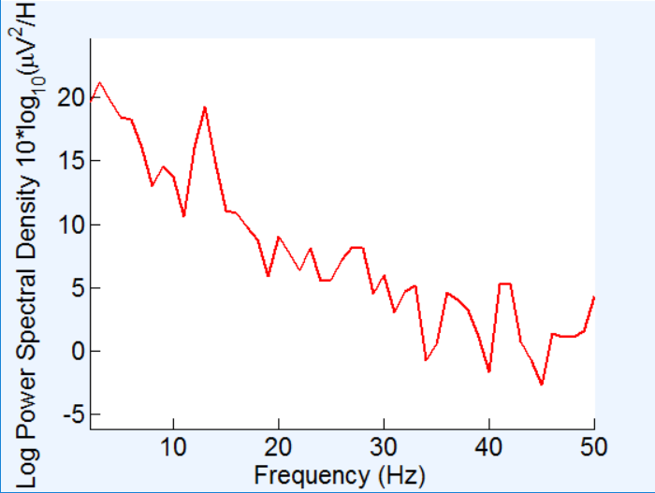
Figure 4.1: Sample Caption

Chapter 5

Conclusion
A detailed evaluation of results and an overall assessment of the research outcomes should be presented.
……… [Chapters 3-5 together should not exceed 40 pages] …………………………

References
List of references should be written according to APA referencing system. Un-cited references should not be listed.

Appendix
All supporting materials which are too extensive for the body text should be included here.

